עמוד 1 מתוך 2 עמודים
IKA Pette vario & Multi pette - Technical Data

 |  | 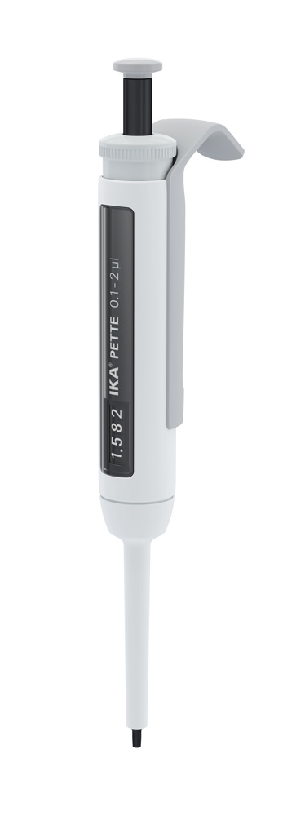 |  | 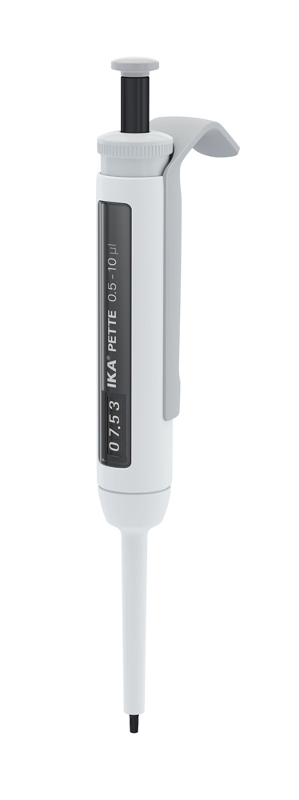 |  | 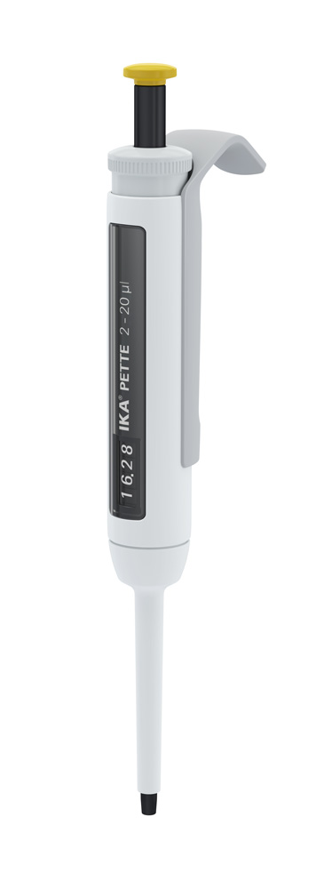 |  | 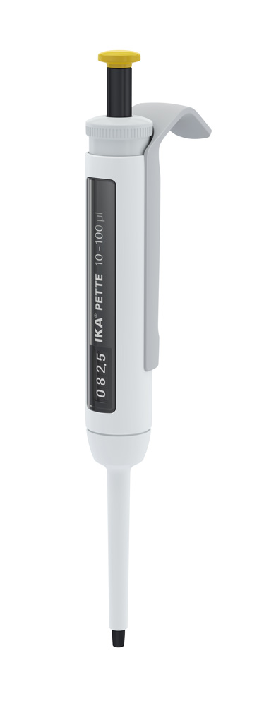 | 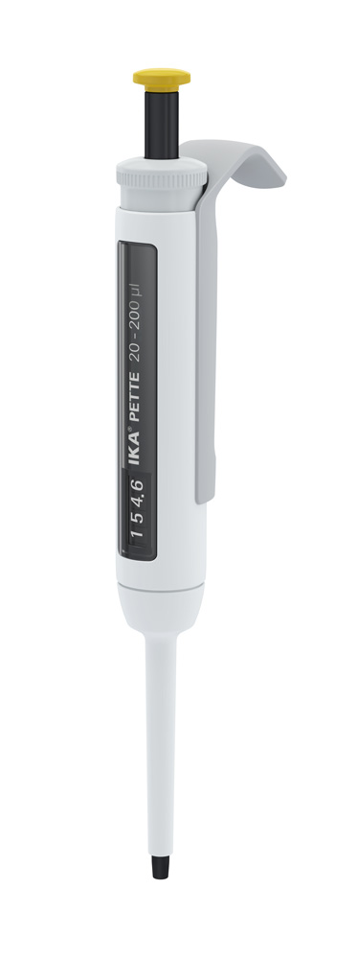 |  | 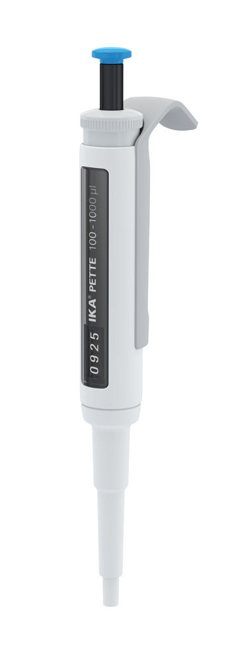 |  | 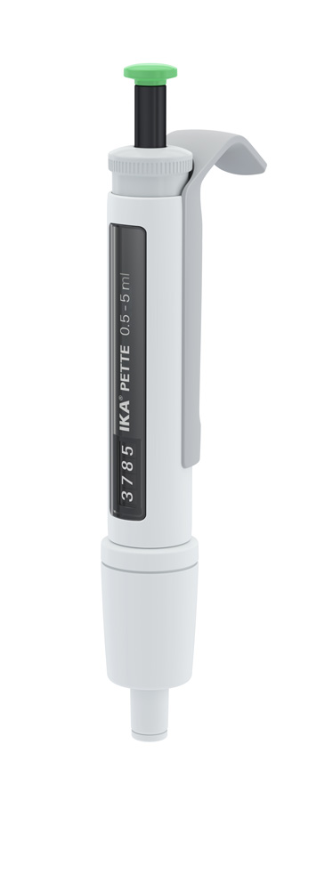 |  | 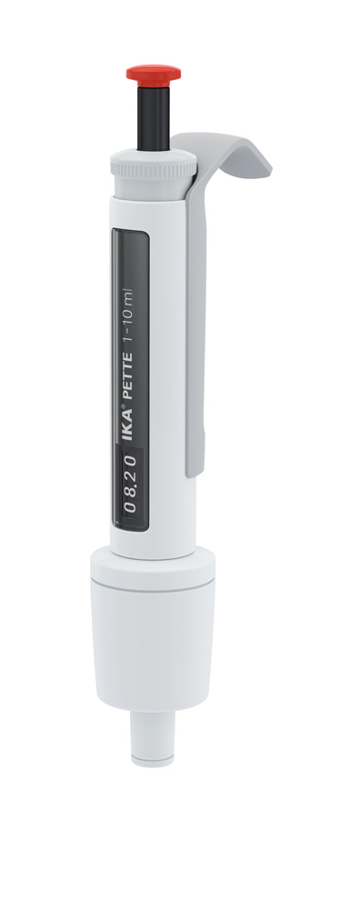
 |  | 0.1-2 µl |  | 0.5-10 µl |  | 2-20 µl |  | 10-100 µl | 20-200 µl |  | 100-1000 µl |  | 0.5-5 ml |  | 1-10 ml
Nominal volume |  | 2 µl |  | 10 µl |  | 20 µl |  | 100 µl | 200 µl |  | 1000 µl |  | 5000 µl |  | 10000 µl
Volume min. |  | 0.1 µl |  | 0.5 µl |  | 2 µl |  | 10 µl | 20 µl |  | 100 µl |  | 500 µl |  | 1000 µl
Volume max. |  | 2 µl |  | 10 µl |  | 20 µl |  | 100 µl | 200 µl |  | 1000 µl |  | 5000 µl |  | 10000 µl
Increments |  | 0.002 µl |  | 0.01 µl |  | 0.02 µl |  | 0.1 µl | 0.2 µl |  | 1 µl |  | 5 µl |  | 10 µl
Accuracy with nominal volume |  | 0.028 ±µl |  | 0.1 ±µl |  | 0.2 ±µl |  | 0.8 ±µl | 1.2 ±µl |  | 6 ±µl |  | 30 ±µl |  | 60 ±µl
Accuracy with nominal volume |  | 1.4 ±% |  | 1 ±% |  | 1 ±% |  | 0.8 ±% | 0.6 ±% |  | 0.6 ±% |  | 0.6 ±% |  | 0.6 ±%
Precision with nominal volume |  | 0.014 ±µl |  | 0.04 ±µl |  | 0.06 ±µl |  | 0.2 ±µl | 0.4 ±µl |  | 2 ±µl |  | 7.5 ±µl |  | 15 ±µl
Precision with nominal volume |  | 0.7 ±% |  | 0.4 ±% |  | 0.3 ±% |  | 0.2 ±% | 0.2 ±% |  | 0.2 ±% |  | 0.15 ±% |  | 0.15 ±%
Accuracy with 50% of nominal volume |  | 0.025 ±µl |  | 0.075 ±µl |  | 0.12 ±µl |  | 0.5 ±µl | 1 ±µl |  | 5 ±µl |  | 30 ±µl |  | 40 ±µl
Accuracy with 50% of nominal volume |  | 2.5 ±% |  | 1.5 ±% |  | 1.2 ±% |  | 1 ±% | 1 ±% |  | 1 ±% |  | 1.2 ±% |  | 0.8 ±%
Precision with 50% of nominal volume |  | 0.015 ±µl |  | 0.04 ±µl |  | 0.06 ±µl |  | 0.15 ±µl | 0.3 ±µl |  | 1 ±µl |  | 6.25 ±µl |  | 10 ±µl
Precision with 50% of nominal volume |  | 1.5 ±% |  | 0.8 ±% |  | 0.6 ±% |  | 0.3 ±% | 0.3 ±% |  | 0.2 ±% |  | 0.25 ±% |  | 0.2 ±%
Accuracy with 10% of nominal volume |  | 0.024 ±µl |  | 0.025 ±µl |  | 0.1 ±µl |  | 0.3 ±µl | 0.5 ±µl |  | 3 ±µl |  | 12 ±µl |  | 30 ±µl
Accuracy with 10% of nominal volume |  | 12 ±% |  | 2.5 ±% |  | 5 ±% |  | 3 ±% | 2.5 ±% |  | 3 ±% |  | 2.4 ±% |  | 3 ±%
Precision with 10% of nominal volume |  | 0.012 ±µl |  | 0.018 ±µl |  | 0.03 ±µl |  | 0.1 ±µl | 0.14 ±µl |  | 0.6 ±µl |  | 3 ±µl |  | 6 ±µl
Precision with 10% of nominal volume |  | 6 ±% |  | 1.8 ±% |  | 1.5 ±% |  | 1 ±% | 0.7 ±% |  | 0.6 ±% |  | 0.6 ±% |  | 0.6 ±%
Certificate of conformity according to ISO 8655 |  | yes |  | yes |  | yes |  | yes | yes |  | yes |  | yes |  | yes
Autoclavable |  | yes |  | yes |  | yes |  | yes | yes |  | yes |  | yes |  | yes
Weight |  | 0.089 kg |  | 0.089 kg |  | 0.09 kg |  | 0.09 kg | 0.091 kg |  | 0.088 kg |  | 0.099 kg |  | 0.108 kg
 |  |  | 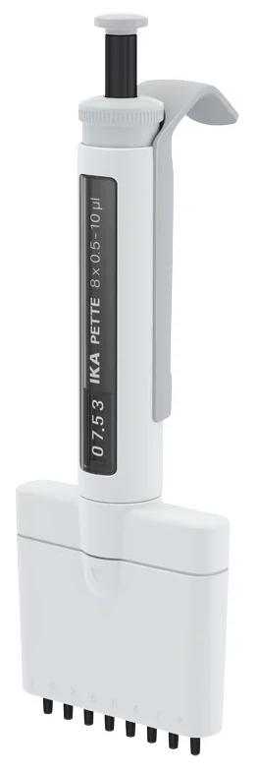 |  | 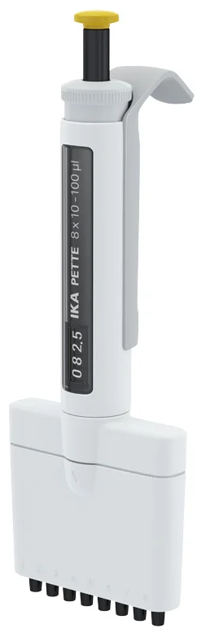 |  | 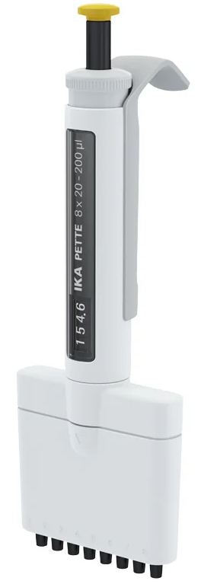 |  |  | 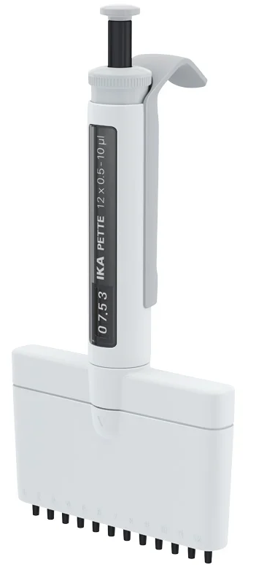
 |  |  | 8x 0.5-10 µl |  | 8x 10-100 µl |  | 8x 20-200 µl |  |  | 12x 0.5-10 µl |  | 12x 10-100 µl |  | 12x 20-200 µl
 | Nominal volume |  | 10 µl |  | 100 µl |  | 200 µl |  |  | 10 µl |  | 100 µl |  | 200 µl
 | Volume min. |  | 0.5 µl |  | 10 µl |  | 20 µl |  |  | 0.5 µl |  | 10 µl |  | 20 µl
 | Volume max. |  | 10 µl |  | 100 µl |  | 200 µl |  |  | 10 µl |  | 100 µl |  | 200 µl
 | Increments |  | 0.01 µl |  | 0.1 µl |  | 0.2 µl |  |  | 0.01 µl |  | 0.1 µl |  | 0.2 µl
 | Accuracy with nominal volume |  | 0.2 ±µl |  | 0.8 ±µl |  | 1.6 ±µl |  |  | 0.2 ±µl |  | 0.8 ±µl |  | 1.6 ±µl
 | Accuracy with nominal volume |  | 2.0 ±% |  | 0.8 ±% |  | 0.8 ±% |  |  | 2.0 ±% |  | 0.8 ±% |  | 0.8 ±%
 | Precision with nominal volume |  | 0.1 ±µl |  | 0.3 ±µl |  | 0.6 ±µl |  |  | 0.1 ±µl |  | 0.3 ±µl |  | 0.6 ±µl
 | Precision with nominal volume |  | 1.0 ±% |  | 0.3 ±% |  | 0.3 ±% |  |  | 1.0 ±% |  | 0.3 ±% |  | 0.3 ±%
 | Accuracy with 50% of nominal volume |  | 0.2 ±µl |  | 0.75 ±µl |  | 1.0 ±µl |  |  | 0.2 ±µl |  | 0.5 ±µl |  | 1.0 ±µl
 | Accuracy with 50% of nominal volume |  | 4.0 ±% |  | 1.0 ±% |  | 1.0 ±% |  |  | 4.0 ±% |  | 1.0 ±% |  | 1.0 ±%
 | Precision with 50% of nominal volume |  | 0.1 ±µl |  | 0.4 ±µl |  | 0.65 ±µl |  |  | 0.1 ±µl |  | 0.4 ±µl |  | 0.65 ±µl
 | Precision with 50% of nominal volume |  | 2.0 ±% |  | 0.8 ±% |  | 0.65 ±% |  |  | 2.0 ±% |  | 0.8 ±% |  | 0.65 ±%
 | Accuracy with 10% of nominal volume |  | 0.08 ±µl |  | 0.3 ±µl |  | 0.5 ±µl |  |  | 0.08 ±µl |  | 0.3 ±µl |  | 0.6 ±µl
 | Accuracy with 10% of nominal volume |  | 8 ±% |  | 3.0 ±% |  | 3 ±% |  |  | 8 ±% |  | 3.0 ±% |  | 3 ±%
 | Precision with 10% of nominal volume |  | 0.05 ±µl |  | 0.2 ±µl |  | 0.25 ±µl |  |  | 0.05 ±µl |  | 0.2 ±µl |  | 0.25 ±µl
 | Precision with 10% of nominal volume |  | 5.0 ±% |  | 2.0 ±% |  | 1.25 ±% |  |  | 5.0 ±% |  | 2.0 ±% |  | 1.25 ±%
 | Certificate of conformity according to ISO 8655 |  | yes |  | yes |  | yes |  |  | yes |  | yes |  | yes
 | Autoclavable |  | yes |  | yes |  | yes |  |  | yes |  | yes |  | yes
 | Weight |  | 0.135 kg |  | 0.147 kg |  | 0.160 kg |  |  | 0.160 kg |  | 0.182 kg |  | 0.195 kg

